In this lab, you will create a canvas for a Guessing game that you will be creating using JavaScript.

To start you will create an html file that will be saved as GuessingGame.html.

Your html file will contain the following code:

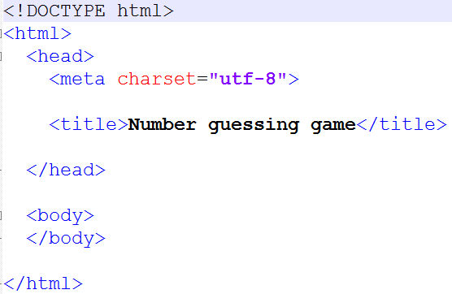

This will create at least a title for the tab that will be called "Number guessing game"

For the next step, you will need to create a separate file that will hold your external cascading style sheet.

Create a new file, named HW10.css, and put in the following code into the .css file:

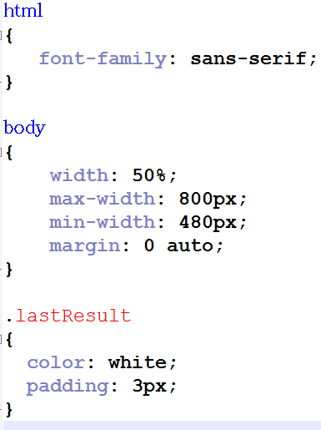

Once you have your external CSS file, you will need to link the stylesheet to your html file by adding following code to the <head> section:

<link rel="stylesheet" type="text/css" href="HW10.css">

Your HTML code should now look like the following:

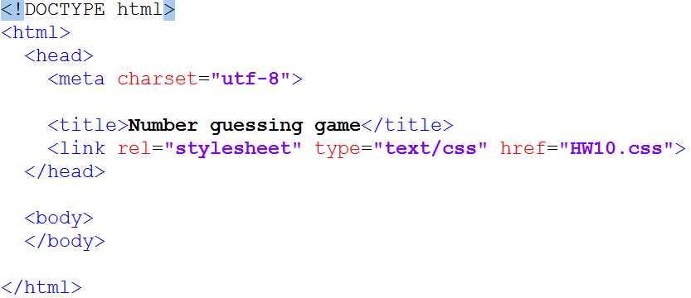

Next, add content to the page. We will start by adding a header and a paragraph that explains the basic rules of the game:

Add the following lines to the <body> section of the HTML file you are working on:

<h1>Number guessing game</h1>

<p>We have selected a random number between 1 and 100. See if you can guess it in 10 turns or less.</p>

<p>We'll tell you if your guess was too high or too low.</p>

Your html file should now look like the following:

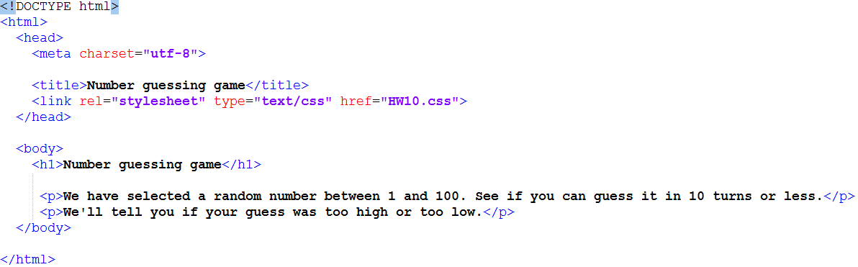

Last but not least, add a form to submit your guess. Directly below that second <p> tag in the body of your html page, add the following lines of code to create a Submit button and a form.

<div class="form">

<label for="guessField">Enter a guess: </label><input type="text" id="guessField" class="guessField">

<input type="submit" value="Submit guess" class="guessSubmit">

</div>

Also, be sure that you need to add another div below the form that will hold the number of guesses, the last number guessed, and whether or not the guess was too high or too low.

<div class="resultParas">

<p class="guesses"></p>

<p class="lastResult"></p>

<p class="lowOrHi"></p>

</div>

Once you have finished adding your code, to the body section of your HTML file, open your HTML file in a browser of your choice. You should see the following result:

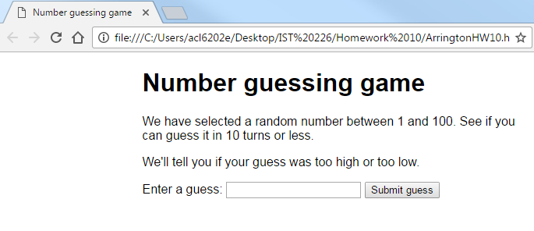

You will be adding on to this code in the next assignment.